

Circuit Playground Express

*Event Blocks*

This lesson introduces one of the key components of most Circuit Playground Express programs: Event Blocks. An Event Block lets you write a program that will run whenever some "event" takes place, such as a button press, a loud sound, or a temperature change.

Blinking a Light on Button Press

The first event we will introduce is the button press event. Open the "INPUT" section of the MakeCode block catalog, and select the "on Button A click" block. Try adding some code inside to turn some lights on:

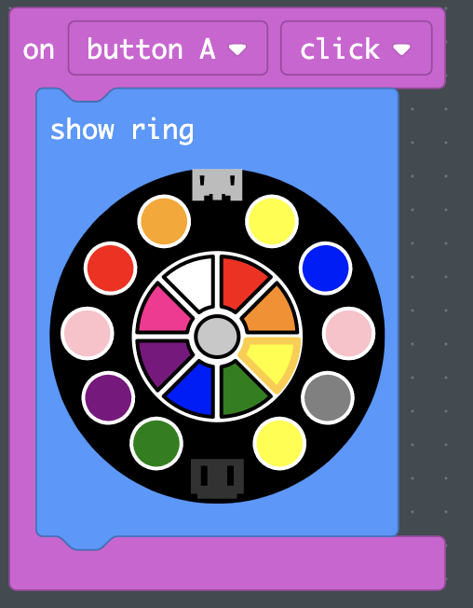

*Did you notice the new "show ring" block we used up there instead of the "set pixel color" we've used in previous examples? The "LIGHT" section of the block catalog has lots of cool options for programming your Circuit Playground Express's LEDs, and you should encourage your students to experiment with different blocks and see what they do. If it's ever not clear how any block works, remember that you can always right click on any block and select "help" to get more information.*

Now give it a try in your simulated Circuit Playground Express: You can use the mouse to click the "A" button in the simulation, and see that your program works. If you like, you can also download the program to your Circuit Playground Express and see it work in the real world.

Play around with the new block. Note that "button A" and "click" are both dropdowns: The way the block is set up by default, the code you put inside will run when the A button on the Circuit Playground Express is clicked (pressed and then immediately released). But you can change "button A" to a number of other inputs (note that the "touch" and "pin" options refer to the pads around the edge of the Circuit Playground Express, which can sense when they are being touched), and you can change "click" to respond to long clicks, or to the button being depressed ("down") or released ("up"). Encourage your students to experiment with these options and get a feel for how they work, both in the simulation and on the real Circuit Playground Express.

How would you use event blocks to write a program that makes your lights only turn on while a button is being pressed and turn off again when the button is released? Have your students try to work this out on their own. Here's one solution:

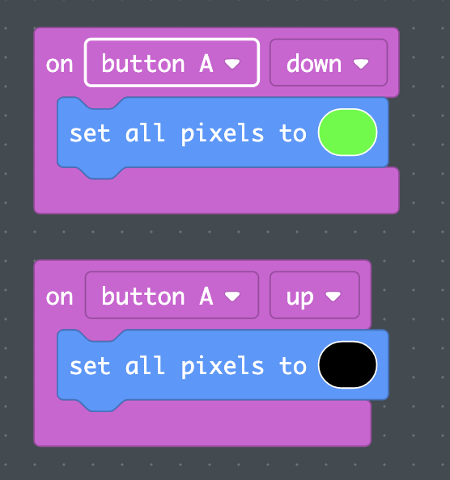

Other Events

You may have noticed that all of the options in the event block we've been playing with relate to button presses. But there are other event blocks for other types of input. Take a look under INPUTS and find "on shake." This block lets you respond to input from the accelerometer built into the Circuit Playground Express (look closely at the center of the circuit board, and you'll see the X Y and Z axis labels right next to the accelerometer). Can you use this block to make your Circuit Playground Express light up when tilted one direction and turn off when tilted the other direction? What else can you do with it?

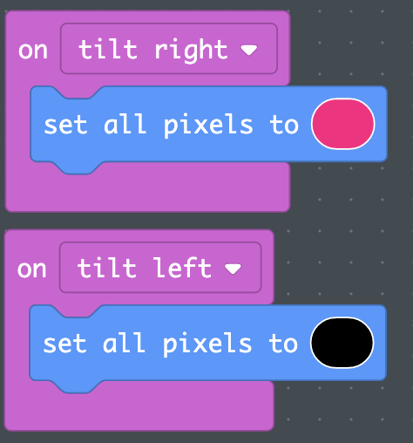

Encourage your students to identify all of the other event blocks and experiment to learn how they work. Note that the simulated Circuit Playground Express in MakeCode will sometimes change to let you trigger these blocks if they are in your program; for example, if you have "on shake" in your program, you should see a "SHAKE" button appear on the simulated Circuit Playground Express. It's also a good idea to download these programs to the real Circuit Playground Express and give them a try to get a feel for how they work on the real hardware.